جامعــــة الازهــر – غـــــــــــــــزة
Al Azhar University – Gaza

FACULTY OF ENGINEERING AND INFORMATION TECHNOLOGY
DEPARTMENT OF COMPUTER SYSTEMS ENGINEERING
FINAL REPORT
“DirectServe Platform”

Mutassembelah M. Alsaifi – 20212502
Munir Z. A. Alghriz – 20224521
Ahmed M. Al-Zayyan – 20212459

SUPERVISED BY:
DR. ABDELBASET AL-MASRI

JANUARY 2026 SEMESTER I 2025/2026

Certificate of Originality

This is to certify that we are responsible for the work submitted in this graduation project entitled:
“DirectServe Platform”
The work presented in this project is our own original work, except where otherwise stated and properly acknowledged through references and citations. We confirm that all sources of information used have been clearly indicated in the references and acknowledgements sections.
Furthermore, we declare that the content of this project has not been copied, taken, or carried out by any unspecified sources or persons, and that this work has not been submitted previously, in whole or in part, for the award of any academic degree or qualification at this or any other institution.

Mutassembelah M. Alsaifi – 20212502
Munir Z. A. Alghriz – 20224521
Ahmed M. Al-Zayyan – 20212459

ACKNOWLEDGEMENT

Praise and thanks be to Allah, first and foremost, whose blessings and guidance enabled us to successfully accomplish this graduation project.

We would like to express our deepest appreciation and sincere gratitude to our supervisor, Dr. Abdelbaset Al-Masri, for his relentless guidance, valuable suggestions, close supervision, and continuous moral encouragement throughout all stages of this project. His support and expertise were essential to the completion of this work.
We would also like to extend our heartfelt thanks to all the lecturers and staff members of the Faculty of Engineering and Information Technology at Al Azhar University – Gaza for their academic support and valuable knowledge during our years of study.
A special thank goes to our parents for their endless support, patience, and encouragement, which motivated us to overcome challenges and complete this project successfully.
Finally, our sincere thanks go to everyone who directly or indirectly contributed to the completion of this project. Their assistance and cooperation are deeply appreciated.

ABSTRACT

This project involves the analysis, design, and implementation of a web-based service management platform entitled “DirectServe Platform”, which aims to facilitate and automate the process of publishing and managing services through a centralized digital system. The main objective of this project is to provide an efficient and user-friendly solution that connects service providers with clients, replacing traditional and unorganized service listing methods.
The DirectServe Platform enables users to create accounts, publish services, upload multiple images, and manage service details through a personalized dashboard. In addition, the system allows visitors to browse and search for services easily, while administrators can manage users, services, categories, and system content to ensure reliability and security.
The system is designed to improve the efficiency of service discovery and management by providing fast access to organized service information and reducing the time and effort required to search for suitable services. The platform is developed using React.js for the front-end, Laravel (PHP) for the back-end, and MySQL for database management, following a multi-tier architecture that enhances scalability and maintainability.

Table of Contents
TABLE NO. | TITLE | PAGE
1 | Introduction  ▪ 1.1 Introduction  ▪ 1.2 Importance of the Project  ▪ 1.3 Project Objectives  ▪ 1.4 Project Scope  ▪ 1.5 Literature Review | 9
2 | Requirements Analysis  ▪ 2.1 Functional Requirements  ▪ 2.1.1 User Management  ▪ 2.1.2 Service Management  ▪ 2.1.3 Authentication and  Authorization  ▪ 2.2 Non-Functional Requirements  ▪ 2.2.1 Performance Requirements  ▪ 2.2.2 Security Requirements  ▪ 2.2.3 Usability Requirements  ▪ 2.2.4 Reliability Requirements  ▪ 2.2.5 Maintainability Requirements  ▪ 2.3 System Actors  ▪ 2.4 Use Cases  2.4.1 List of Use Cases  2.4.2 Use Cases Descriptions  2.5 Use Case Diagram  2.6 Tools and Technologies Used | 12
3 | System Design  ▪ 3.1 High-Level Design  ▪ 3.2 UML Diagrams  ▪ 3.2.1 Communication Diagrams  ▪ 3.2.2 Object Identification  ▪ 3.2.3 Class Identification  ▪ 3.2.4 Class Diagram  ▪ 3.2.5 Sequence Diagrams  ▪ 3.3 Database Design  ▪ 3.4 Main User Interface Descriptions | 30
4 | Timeline and Challenges  ▪ 4.1 Work Plan and Task Distribution  ▪ 4.2 Project Timeline  ▪ 4.3 Challenges and How They Were Addressed  ▪ 4.4 Summary | 57
References | Appendices  ▪ Appendix A UML Diagrams  ▪ Appendix B Database ERD  ▪ Appendix C Figma UI/UX Screens | 61

LIST OF TABLES

TABLE NO. | TITLE | PAGE
Table 2.1 | System Actors Description | 15
Table 2.4.2.1 | Use Case UC01 – Create Account | 17
Table 2.4.2.2 | Use Case UC02 – Login | 18
Table 2.4.2.3 | Use Case UC03 – View Services | 19
Table 2.4.2.4 | Use Case UC04 – Search Services | 19
Table 2.4.2.5 | Use Case UC05 – View Service Details | 20
Table 2.4.2.6 | Use Case UC06 – Contact Us | 21
Table 2.4.2.7 | Use Case UC07 – Logout | 21
Table 2.4.2.8 | Use Case UC08 – Edit Profile | 22
Table 2.4.2.9 | Use Case UC09 – View Dashboard | 22
Table 2.4.2.10 | Use Case UC10 – Add Service | 23
Table 2.4.2.11 | Use Case UC11 – Add Service | 24
Table 2.4.2.12 | Use Case UC12 – Delete Service | 25
Table 2.4.2.13 | Use Case UC13 – Manage Service Gallery | 25
Table 2.4.2.14 | Use Case UC14 – View Own Services | 26
Table 2.4.2.15 | Use Case UC15 – Manage Users | 27
Table 2.4.2.16 | Use Case UC16 – Manage Service | 28
Table 2.4.2.17 | Use Case UC17 – View Messages | 28
Table 2.4.2.18 | Use Case UC18 – Manage Categories | 29
Table 2.4.2.19 | Use Case UC19 – Manage Roles | 30
Table 2.4.2.20 | Use Case UC20 – Manage Tags | 30
Table 4.1.1 | Team Members and Responsibilities | 61

LIST OF FIGURES

FIGURES NO. | TITLE | PAGE
Figure 2.1 | Use Case Diagram of the DirectServe Platform | 30
Figure 3.1 | Login Communication Diagram | 33
Figure 3.2 | View Service Details Communication Diagram | 33
Figure 3.3 | Add Service Communication Diagram | 34
Figure 3.4 | Edit Service Communication Diagram | 34
Figure 3.5 | Delete Service Communication Diagram | 34
Figure 3.6 | Manage Users Communication Diagram | 35
Figure 3.7 | Class Diagram of the DirectServe Platform | 39
Figure 3.8 | Login Sequence Diagram | 41
Figure 3.9 | View Service Details Sequence Sequence Diagram | 42
Figure 3.10 | Add Service Sequence Sequence Diagram | 43
Figure 3.11 | Edit Service Sequence Sequence Diagram | 44
Figure 3.12 | Delete Service Sequence Sequence Diagram | 45
Figure 3.13 | Add Service Sequence Sequence Diagram | 46
Figure 3.14 | ERD Diagram | 50
Figure 3.15 | Login Page | 52
Figure 3.16 | Home Page | 53
Figure 3.17 | Find a Service Page | 54
Figure 3.18 | Service Details Page | 55
Figure 3.19 | Service Details Page | 56
Figure 3.20 | add new service Page | 57
Figure 3.21 | edit service Page | 58

Chapter 1: Introduction and Background

1.1 Introduction
In recent years, digital transformation has significantly changed the way individuals and organizations offer and request services. With the rapid growth of internet technologies, many traditional service-based activities have moved toward online platforms that provide faster communication, wider accessibility, and better organization.
The DirectServe Platform is a web-based system designed to connect service providers directly with clients through a centralized digital environment. The platform allows users to publish services, manage service details, upload multiple images, and communicate efficiently. The system focuses on simplicity, usability, and clarity to ensure a smooth experience for all types of users.

1.2 Importance of the Project
The importance of the DirectServe Platform lies in addressing several real-world challenges faced by both service providers and clients, including:
- Difficulty in finding reliable service providers in one place
- Lack of organized platforms for publishing and managing services
- Limited visibility for freelancers and small-scale service providers
- Absence of visual presentation tools such as image galleries
By offering a structured and easy-to-use platform, DirectServe improves service accessibility, enhances user experience, and supports digital service exchange in an efficient manner.

1.3 Project Objectives

Main Objectives
- Develop a web-based platform for publishing and managing services
- Provide a user-friendly interface with modern UI/UX design
- Allow users to upload multiple images for each service
- Implement an admin panel for managing users and services

Secondary Objectives
- Design a scalable and well-structured database
- Ensure responsive design across different devices
- Improve system usability and accessibility

1.4 Project Scope

In-Scope
- User registration and authentication
- Adding, editing, and deleting services
- Uploading and managing service images
- Browsing and searching services
- Admin management of users and content

Out of Scope (Future Work)
- Online payment integration
- Mobile application version
- Advanced recommendation systems
1.5 Literature Review & Comparative Analysis
In this section, we conducted a comprehensive study of existing service-based platforms to understand their strengths and weaknesses. This helped us define the unique positioning of the DirectServe Platform.
A. Overview of Similar Systems:
- Sahibinden (Turkey): The largest classified ads platform in Turkey. It offers a vast range of services and products, acting primarily as a listing directory where users can post and browse service advertisements.
- Armut (Turkey) / HomeRun: A leading Turkish service marketplace that uses a matching algorithm to connect service providers (like cleaners, renovators, and technicians) with customers based on specific job requests and bidding.
- TaskRabbit (International): A well-known global platform that connects freelance labor with local demand, allowing consumers to find immediate help with everyday technical and household tasks.
B. Our Value Proposition (The New Contribution):
While platforms like Sahibinden provide great visibility for ads, they lack specialized management tools for technicians. DirectServe fills this gap by providing:
- Integrated Workflow: Moving from a simple "add listing" (like Sahibinden) to a full "management system" where the entire service lifecycle is tracked.
- No Bidding Friction: Unlike Armut, which requires providers to bid on jobs, DirectServe allows for a more direct booking experience, saving time for both the client and the provider.
- Modern Tech Stack: Developed using React.js and Laravel to ensure a high-performance.
Chapter 2: REQUIREMENTS ANALYSIS

2.1 Functional Requirements

2.1.1 User Management
- The system shall allow users to create new accounts
- Users shall be able to log in using email and password
- Users shall be able to edit their profile information
- Admins shall manage user accounts

2.1.2 Service Management
- Users shall add, edit, and delete services
- The system shall support multiple images per service
- Users shall browse and search services
- Services shall be categorized

2.1.3 Authentication and Authorization
- Role-based login (User / Admin)
- Restricted access to protected pages
- Secure session handling

2.2 Non-Functional Requirements

2.2.1 Performance
- System response time ≤ 3 seconds
- Support at least 1000 concurrent users

2.2.2 Security
- Password encryption
- Protection against SQL Injection
- Role-based access control

2.2.3 Usability
- Intuitive and easy-to-use interface
- Responsive design
- Light and Dark mode support

2.3 System Actors
- Visitor: Browses services without publishing
- User: Publishes and manages services
- Admin: Manages users and system content
Table 2.1: System Actors Description
Actor | Description
User | A registered individual who can add,edit and view services
Admin | A system administrator with full control over users, services, and messages
Visitor | An unregistered user who can browse and search services but cannot post
System | The internal engine responsible for processing actions and generating responses

2.4 Use Cases
The system supports multiple use cases including account creation, login, service management, browsing services, and administrative control.

2.4.1 List of Use Cases
This section presents the list of use cases supported by the DirectServe Platform. The use cases are categorized based on the system actors: Visitor, User, and Admin.

Visitor Use Cases
- UC01 – Create Account
- UC03 – View Services
- UC04 – Search Services
- UC05 – View Service Details
- UC06 – Contact Us

User Use Cases
- UC02 – Login
- UC07 – Logout
- UC08 – Edit Profile
- UC03 – View Services
- UC04 – Search Services
- UC05 – View Service Details
- UC06 – Contact Us
- UC09 – View Dashboard
- UC10 – Add Service
- UC11 – Edit Service
- UC12 – Delete Service
- UC13 – Manage Service Gallery
- UC14 – View Own Services

Admin Use Cases
- UC02 – Login
- UC07 – Logout
- UC03 – View Services
- UC08 – Edit Profile
- UC15 – Manage Users
- UC16 – Manage Services
- UC17 – View Messages
- UC18 – Manage Categories
- UC19 – Manage Roles
- UC20 – Manage Tags

2.4.2 Use Cases Descriptions
Table 2.4.2.1: Use Case UC01 – Create Account
Field | Description
Use Case ID | UC01
Name | Create Account
Actors | Visitor
Brief Description | Allows a new visitor to register and create an account
Pre-Conditions | Visitor is not logged in
Post-Conditions | User account is created and stored
Main Flow | 1. Visitor opens registration page.  2. System displays form.  3. Visitor enters data.  4. System validates data.  5. System creates account.
Alternative / Exception Flows | • A1: Email exists → System shows error. A2: Missing fields → System asks to complete data.
Table 2.4.2.2: Use Case UC02 – Login
Field | Description
Use Case ID | UC02
Name | Login
Actors | User, Admin
Brief Description | Authenticates a registered user or admin using email and password
Pre-Conditions | User/Admin already has an account. Login page is accessible
Post-Conditions | User/Admin is authenticated and redirected to the appropriate dashboard with a valid token/session
Main Flow | 1. Actor opens the login page. 2. System displays login form. 3. Actor enters email and password.  4. Actor clicks “Login”.  5. System validates the input format.  6. System verifies credentials against the database.  7. System creates authentication token/session. 8. System redirects User to user dashboard or Admin to admin dashboard.
Alternative / Exception Flows | A1 – Invalid Credentials:  • At step 6, email or password is incorrect → System displays error “Invalid email or password”  • A2 – Inactive User: User account is deactivated → System prevents login and shows appropriate message.
Table 2.4.2.3: Use Case UC03 – View Services
Field | Description
Use Case ID | UC03
Name | View Services
Actors | User, Admin,visitor
Brief Description | Displays a list of all available published services.
Pre-Conditions | Services exist in the system. actor open the services page
Post-Conditions | List of services is shown with basic information (title, image, price, rating)
Main Flow | 1. Actor navigates to “Services” or home page.  2. System sends a request to the backend to retrieve services.  3. Backend fetches all published services from the database.  4. System returns the services list to the front-end.  5. Front-end displays services in a grid/cards view.
Alternative / Exception Flows | A1 – No Services Available:  • At step 3, no services exist → System returns empty list and displays “No
Table 2.4.2.4: Use Case UC04 – Search Services
Field | Description
Use Case ID | UC04
Name | Search Services
Actors | User,visitor
Brief Description | Allows actor to search services using keywords and filters.
Pre-Conditions | Services exist in the system. Search bar is available
Post-Conditions | Matching services (if any) are displayed to the actor
Main Flow | 1. Actor enters a keyword (e.g., “plumbing”) and/or chooses filters.  2. Actor starts the search (press enter / click search button).  3. System sends search request to backend.  4. Backend queries database using keyword and filters.  5. Backend returns list of matching services.  6. Front-end displays the results to the actor
Alternative / Exception Flows | A1 – No Results Found:  • At step 5, empty result set → System displays a message such as “No services found for this search”.  A2 – Invalid Filter:  • Invalid filter values → System ignores invalid filter and performs basic search.
Table 2.4.2.5: Use Case UC05 – View Service Details
Field | Description
Use Case ID | UC05
Name | View Service Details
Actors | User,visitor
Brief Description | Shows detailed information about a selected service
Pre-Conditions | Service exists and is published. Actor is viewing services list
Post-Conditions | Detailed service page is displayed with all available information
Main Flow | 1. Actor clicks on a specific service card.  2. Front-end sends GET /api/services/{id} request.  3. Backend controller calls service layer to retrieve service by ID.  4. Service layer queries database (service + images + category + tags).  5. Database returns matching records.  6. Backend assembles full service DTO and returns JSON response.  7. Front-end renders service details page with images, description, price, provider info, etc.
Alternative / Exception Flows | A1 – Service Not Found:  • At step 4, record is missing → Backend returns 404 Not Found → Front-end shows “Service not found”
Table 2.4.2.6: Use Case UC06 – Contact Us
Field | Description
Use Case ID | UC06
Name | Contact Us
Actors | User,visitor
Brief Description | Sends a message or inquiry to the system admin through a contact form
Pre-Conditions | Contact Us page is accessible
Post-Conditions | Message is stored in database and can be viewed by Admin
Main Flow | 1. Actor opens Contact Us page.  2. System displays form (name, email, subject, message).  3. Actor fills in all required fields.  4. Actor submits the form.  5. System validates the fields. 6. System stores the message in the Messages table.  7. System shows confirmation message “Your message has been sent”.
Alternative / Exception Flows | A1 – Missing/Invalid Fields:  • At step 5, validation fails → System displays error messages and does not save the message.
Table 2.4.2.7: Use Case UC07 – Logout
Field | Description
Use Case ID | UC07
Name | Logout
Actors | User,admin
Brief Description | Logs the user out from the system
Pre-Conditions | User is already logged in
Post-Conditions | Authentication token/session is invalidated and user is redirected to public page
Main Flow | 1. User clicks on “Logout” button.  2. Front-end removes token from storage (or sends logout request).  3. System clears session information.  4. System redirects user to login or home page.
Alternative / Exception Flows | A1 – Token Already Invalid:  • System simply redirects to login page without error
Table 2.4.2.8: Use Case UC08 – Edit Profile
Field | Description
Use Case ID | UC08
Name | Edit Profile
Actors | User,admin
Brief Description | Allows user to update personal information
Pre-Conditions | User is logged in. Profile page is available
Post-Conditions | updated profile data is saved in the database
Main Flow | 1. User opens “Profile” page.  2. System displays current profile information.  3. User edits fields (name, phone, avatar, etc.).  4. User clicks “Save”.  5. System validates the input. 6. System updates the user record. 7. System confirms the update.
Alternative / Exception Flows | A1 – Invalid Data:  • At step 5, invalid phone/email → System shows validation errors and keeps old data.

Table 2.4.2.9: Use Case UC09 – View Dashboard
Field | Description
Use Case ID | UC09
Name | View Dashboard
Actors | User
Brief Description | Shows user dashboard including statistics and list of his services
Pre-Conditions | User is logged in
Post-Conditions | Dashboard data is displayed successfully
Main Flow | 1. User navigates to dashboard.  2. System validates token/authorization.  3. Backend retrieves user-specific data (number of services, list of services, etc.).  4. Front-end renders dashboard with cards and lists
Alternative / Exception Flows | A1 – Unauthorized Access: • Invalid token → System redirects to login page
Table 2.4.2.10: Use Case UC10 – Add Service
Field | Description
Use Case ID | UC10
Name | Add Service
Actors | User
Brief Description | Enables user to create a new service listing
Pre-Conditions | User is logged in. Required categories exist
Post-Conditions | New service record (and its images if any) is stored and visible as published/draft
Main Flow | 1. User opens “Add Service” page.  2. System shows form (title, description, category, price, location, tags, images…).  3. User fills all required fields. 4. User uploads one or more images (optional if allowed).  5. User clicks “Submit” or “Save as Draft”. 6. System validates the data.  7. System stores service data in Services table.  8. System stores image data and links them to the service. 9. System confirms creation and redirects to dashboard or service details.
Alternative / Exception Flows | A1 – Invalid Data:  • At step 6, missing mandatory fields → System shows errors and does not create service. A2 – Invalid Image:  • Uploaded file is not valid image → System rejects that file and shows message.

Table 2.4.2.11: Use Case UC11 – Add Service
Field | Description
Use Case ID | UC11
Name | Edit Service
Actors | User
Brief Description | Allows the owner to modify details of an existing service.
Pre-Conditions | User is logged in and owns at least one service
Post-Conditions | Updated service data is stored in the database.
Main Flow | 1. User opens “My Services” list.  2. User selects a service and clicks “Edit”.  3. System retrieves current service data and displays it in a form.  4. User updates the fields.  5. User clicks “Save Changes”. 6. System validates input.  7. System updates the service record.  8. System confirms update.
Alternative / Exception Flows | A1 – Service Not Found or Not Owned:  • At step 2/3, service doesn’t belong to user → System denies access. A2 – Invalid Data:  • At step 6, invalid input → System shows error messages.

Table 2.4.2.12: Use Case UC12 – Delete Service
Field | Description
Use Case ID | UC12
Name | Delete Service
Actors | User
Brief Description | Removes an existing service created by the user
Pre-Conditions | User is logged in and is the owner of the service
Post-Conditions | Service (and its images) are marked as deleted or removed from the database.
Main Flow | 1. User opens “My Services”. 2. User selects a service and clicks “Delete”. 3. System asks for confirmation. 4. User confirms deletion. 5. System deletes or deactivates the service record. 6. System confirms deletion and refreshes list
Alternative / Exception Flows | A1 – User Cancels:  • At step 4, user cancels → System aborts operation. A2 – Service Not Found / No Permission:  • System displays error message.
Table 2.4.2.13: Use Case UC13 – Manage Service Gallery
Field | Description
Use Case ID | UC13
Name | Manage Service Gallery
Actors | User
Brief Description | Add or remove images in the gallery of a specific service
Pre-Conditions | User is logged in and owns the service. Existing service already created
Post-Conditions | Gallery associated with the service is updated in the database
Main Flow | 1. User opens edit page for a service.  2. System shows current images gallery.  3. User chooses “Add image” to upload new files and/or selects existing images to remove.  4. User confirms changes.  5. System validates new images and processes deletions.  6. System updates ServiceImages records. 7. System shows updated gallery.
Alternative / Exception Flows | A1 – Invalid Image:  • System rejects invalid images and shows message. A2 – Image Not Found:  • Trying to delete non-existing image → System ignores and logs error.

Table 2.4.2.14: Use Case UC14 – View Own Services
Field | Description
Use Case ID | UC14
Name | View Own Services
Actors | User
Brief Description | Shows list of services created by the current logged-in use
Pre-Conditions | User is logged in
Post-Conditions | User’s services are displayed (or empty list if none)
Main Flow | 1. User navigates to “My Services”.  2. Backend receives request with user ID.  3. Backend retrieves services that belong to this user.  4. System returns list.  5. Front-end displays them in list/cards view with options (Edit/Delete).
Alternative / Exception Flows | A1 – No Services:  • System displays message like “You have no services yet”.

Table 2.4.2.15: Use Case UC15 – Manage Users
Field | Description
Use Case ID | UC15
Name | Manage Users
Actors | Admin
Brief Description | Admin manages user accounts (view, activate, deactivate, delete)
Pre-Conditions | Admin is logged in and has permission to manage users
Post-Conditions | User accounts are updated according to admin actions
Main Flow | 1. Admin opens “Users Management” page. 2. System retrieves list of all users.  3. Admin selects a user.  4. Admin chooses an action (activate/deactivate/delete/edit).  5. System applies the change to the user record.  6. System confirms operation and refreshes list.
Alternative / Exception Flows | A1 – User Not Found:  • Selected user no longer exists → System shows error message
Table 2.4.2.16: Use Case UC16 – Manage Services
Field | Description
Use Case ID | UC16
Name | Manage Services
Actors | Admin
Brief Description | Admin can view and moderate all services in the platform
Pre-Conditions | Admin is logged in
Post-Conditions | Service statuses are updated (approved, removed, etc.)
Main Flow | 1. Admin opens “Services Management” page.  2. System retrieves all services.  3. Admin selects a service.  4. Admin chooses an action (view details, delete, deactivate, etc.).  5. System updates the service state in database.  6. System refreshes list and shows updated status.
Alternative / Exception Flows | A1 – Service Not Found:  • System shows error.

Table 2.4.2.17: Use Case UC17 – View Messages
Field | Description
Use Case ID | UC17
Name | View Messages
Actors | Admin
Brief Description | Admin views all messages sent via Contact Us
Pre-Conditions | Messages exist in database. Admin is logged in
Post-Conditions | Messages are displayed for review or follow-up
Main Flow | 1. Admin opens “Messages” page.  2. System retrieves all messages from Messages table.  3. System displays them in a list with sender info and date.
Alternative / Exception Flows | A1 – No Messages: • System displays “No messages available”.
Table 2.4.2.18: Use Case UC18 – Manage Categories
Field | Description
Use Case ID | UC18
Name | Manage Categories
Actors | Admin
Brief Description | Admin adds, edits, or deletes service categories
Pre-Conditions | Admin is logged in and categories management page is available
Post-Conditions | Categories table is updated. Changes affect services’ available categories
Main Flow | 1. Admin opens “Categories” management page.  2. System displays list of existing categories.  3. Admin chooses action: add new / edit existing / delete.  4. Admin fills in category data (name, description).  5. System validates and saves changes.  6. System updates list displayed.
Alternative / Exception Flows | A1 – Category Already Exists:  • When adding with duplicate name → System shows error. A2 – Category Linked to Services (on delete):  • System may prevent deletion or require reassignment of services.
Table 2.4.2.19: Use Case UC19 – Manage Roles
Field | Description
Use Case ID | UC19
Name | Manage Roles
Actors | Admin
Brief Description | Admin assigns or modifies roles (e.g., User, Admin) for system accounts
Pre-Conditions | Admin is logged in. Role definitions exist
Post-Conditions | User roles are updated, affecting permissions and access control
Main Flow | 1. Admin opens “Roles Management” or user details page.  2. System displays list of users and their current roles.  3. Admin selects a user.  4. Admin chooses new role from list.  5. System updates user role in database.  6. System confirms update.
Alternative / Exception Flows | A1 – Role Not Found:  • Selected role does not exist → System shows error.
Table 2.4.2.20: Use Case UC20 – Manage Tags
Field | Description
Use Case ID | UC20
Name | Manage Tags
Actors | Admin
Brief Description | Admin defines and manages global tags that can be used by services
Pre-Conditions | Admin is logged in. Tags management page is available
Post-Conditions | Tags table is updated; services can use these tags
Main Flow | 1. Admin opens “Tags” management page.  2. System displays existing tags.  3. Admin chooses action: add, edit, or delete tag.  4. For add/edit: Admin enters tag name and optional description.  5. System validates and saves changes.  6. Updated list of tags is shown.
Alternative / Exception Flows | A1 – Duplicate Tag Name:  • When adding/editing to an existing name → System shows error.  A2 – Tag In Use (on delete):  • System may prevent deletion or require removing tag from all services first.

2.5 Use Cases
The system supports multiple use cases including account creation, login, service management, browsing services, and administrative control.
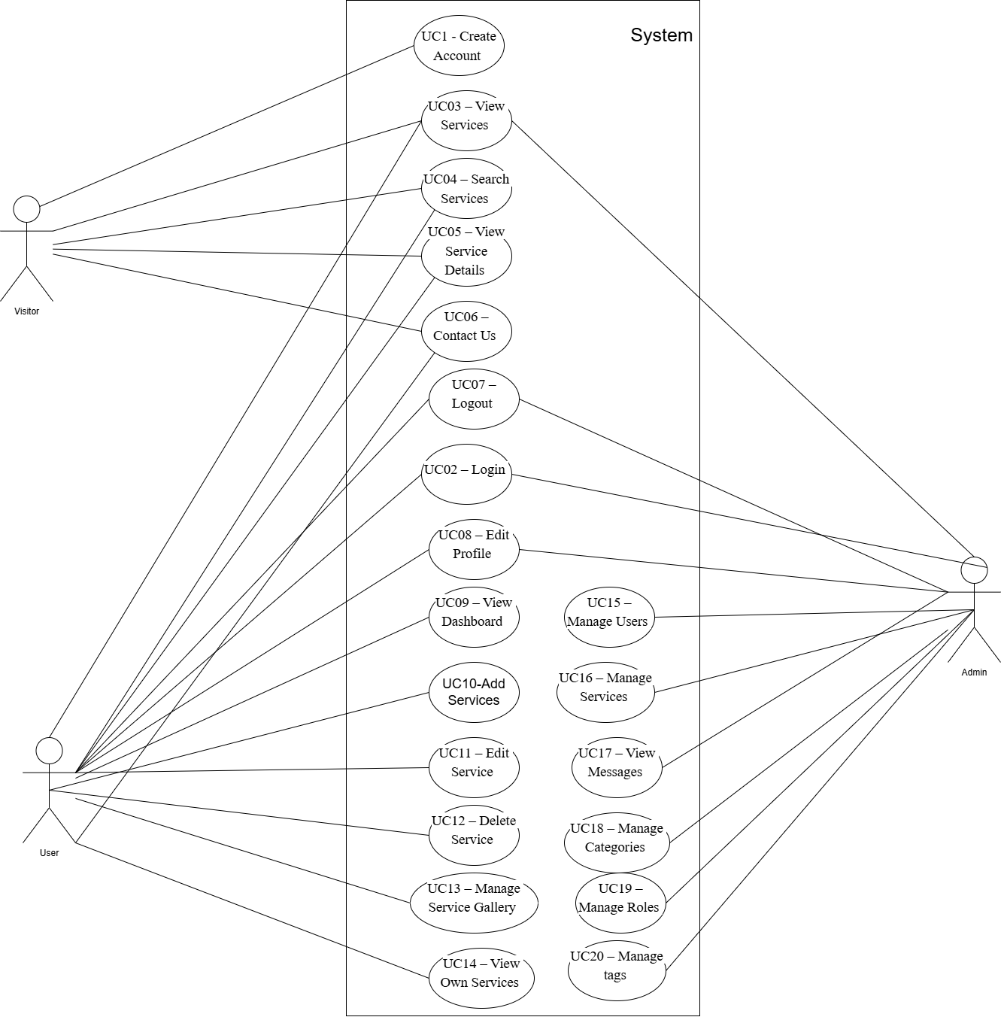Figure 2.1: Use Case Diagram of the DirectServe Platform

2.6 Tools and Technologies Used
Table 2.6.1: Use Case UC17 – View Messages
Category | Tools
Frontend | React.js, JavaScript (ES6+), HTML5 & CSS3, Axios, React Router
Backend | PHP (Laravel)
Database | MySQL
Design and Prototyping | Figma
UML Diagramming | Draw.io
Version Control | Git, GitHub
Project Management | Trello

Chapter 3: System Design

This chapter presents the overall system design of the DirectServe Platform, including the high-level architecture, UML diagrams, database design, and the description of the main user interfaces. The purpose of this chapter is to provide a clear understanding of how the system operates internally at both structural and functional levels.

3.1 High-Level Design
The DirectServe Platform follows a multi-tier web architecture consisting of:
- Presentation Layer (React.js)
- Application Layer (Laravel Controllers)
- Domain Layer (Eloquent Models)
- Database Layer (MySQL)
This architecture improves scalability, maintainability, and separation of concerns.
3.2 UML Diagrams
This section includes the UML diagrams representing system interactions and structural components.

3.2.1 Communication Diagrams
Communication diagrams illustrate how the UI interacts with Laravel controllers and how controllers interact with Eloquent models and the database. Included diagrams:
3.2.1.1 Login Communication Diagram
Shows the login request flow, token validation, and error handling
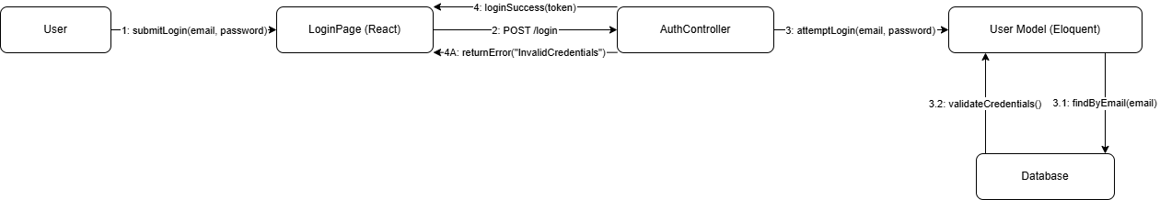Figure 3.1: Login Communication Diagram

3.2.1.2 View Service Details Communication Diagram
Displays how service details, images, and categories are fetched.
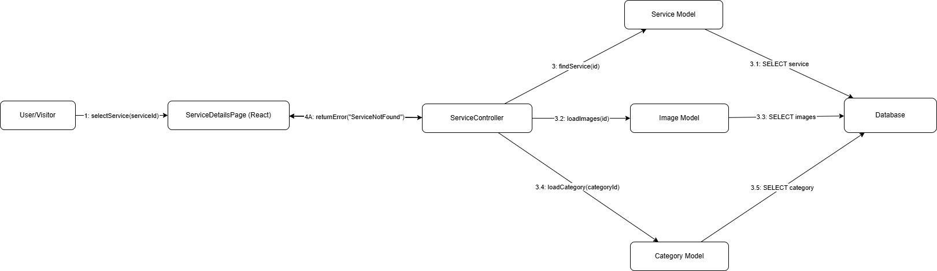Figure 3.2: View Service Details Communication Diagram

3.2.1.3 Add Service Communication Diagram
Shows how a new service is created, validated, and stored.
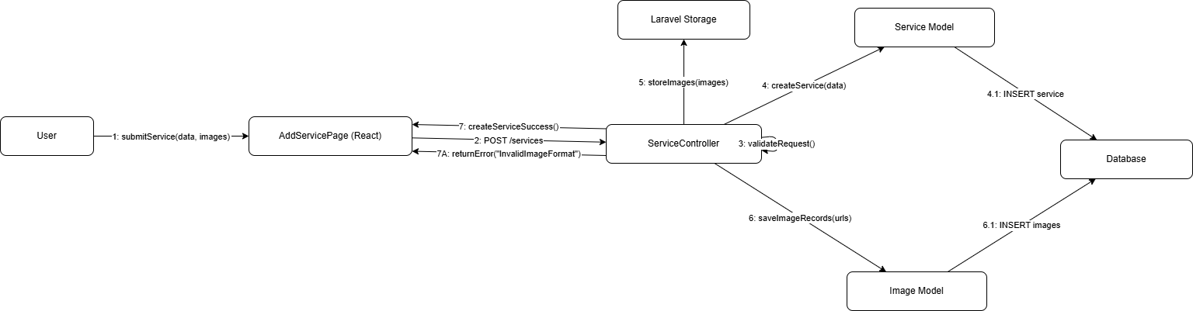Figure 3.3: Add Service Communication Diagram

3.2.1.4 Edit Service Communication Diagram
Covers updating a service and handling unauthorized access.
Figure 3.4: Edit Service Communication Diagram

3.2.1.5 Delete Service Communication Diagram
Explains the deletion process and service-not-found errors.
Figure 3.5: Delete Service Communication Diagram

3.2.1.6 Manage Users Communication Diagram Describes how the admin retrieves and manages user accounts.
Figure 3.6: Manage Users Communication Diagram
3.2.2 Object Identification
Objects were identified and extracted based on the communication diagrams and system workflows. Since the DirectServe Platform is developed using the Laravel framework without a dedicated Service Layer or Repository Layer, the identified objects are categorized into the following main components:
- User Interface (UI) Components
- Controllers
- Eloquent Models
- Database
These objects represent the essential elements involved in handling system operations and user interactions.

3.2.2.1 Login – Objects
The following objects are involved in the login process:
- User
- LoginPage
- AuthController
- User Model
- Database
These objects collaborate to authenticate users, validate credentials, and manage user sessions.

3.2.2.2 View Service Details – Objects
The objects participating in viewing service details include:
- User / Visitor
- ServiceDetailsPage
- ServiceController
- Service Model
- Image Model
- Category Model
- Database
These objects handle retrieving service information, associated images, and category data to present detailed service information to the user.

3.2.2.3 Add Service – Objects
The following objects are involved in adding a new service:
- User
- AddServicePage
- ServiceController
- Service Model
- Image Model
- Storage (Laravel Storage for service images)
- Database
These objects manage service creation, validation, image uploading, and data storage.

3.2.2.4 Edit Service – Objects
The objects involved in editing an existing service include:
- User
- EditServicePage
- ServiceController
- Service Model
- Database
These components enable users to update service information while ensuring authorization and data consistency.

3.2.2.5 Delete Service – Objects
The deletion of a service involves the following objects:
- User
- MyServicesPage
- ServiceController
- Service Model
- Database
These objects handle service removal requests, validation, and data updates in the database.

3.2.2.6 Manage Users – Objects
The following objects are involved in managing user accounts by the administrator:
- Admin
- AdminUserPanel
- AdminUserController
- User Model
- Database
These objects allow the administrator to view, activate, deactivate, or delete user accounts.

3.2.3 Class Identification
Classes were derived from the previously identified objects and represent the main structural components of the DirectServe Platform. These classes define the system’s data structures and behaviors and are used to model both the domain entities and the control logic of the system.

3.2.4 Class Diagram
The Class Diagram illustrates:
• Eloquent Models and their relationships
• Controller dependencies
• One-to-many associations
• Laravel-based architecture (Controller → Model → DB)
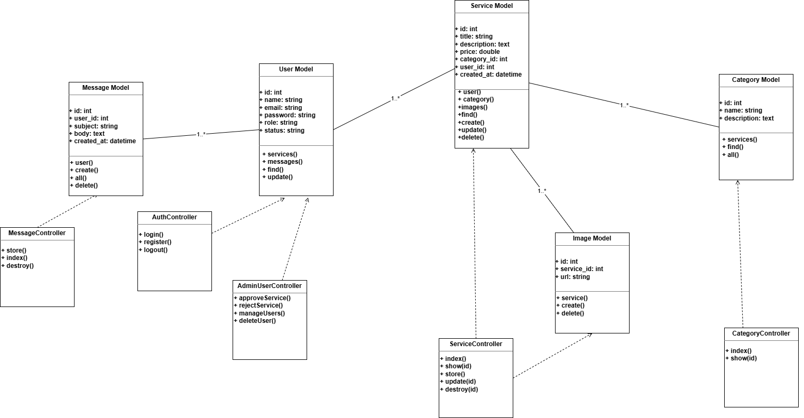Figure 3.7:Class Diagram of the DirectServe Platform

3.2.5 Sequence Diagrams
Sequence Diagrams illustrate the chronological flow of interactions between the system components during the execution of each use case in the DirectServe Platform. They demonstrate how the React client communicates with the Laravel controllers, how the controllers interact with the Eloquent models, and how data is retrieved from or stored in the database.
Each sequence diagram represents the main successful execution scenario of the use case, in addition to alternative flows that describe how the system handles exceptional situations such as invalid input, unauthorized access, or missing resources. These diagrams provide a clear understanding of the internal system behavior and help ensure the correctness and consistency of the implemented functionality.

3.2.5.1 Login Sequence Diagram
This sequence diagram describes the authentication process when a user or administrator attempts to log in to the system. It shows how the login credentials are submitted from the client side, validated by the backend, and verified against the database before granting access.
Main Flow Includes:
- Submitting login credentials from the client
- Validating user credentials
- Generating an authentication token
- Redirecting the user to the appropriate dashboard

Alternative Flow:
- Invalid email or password → system returns an authentication error
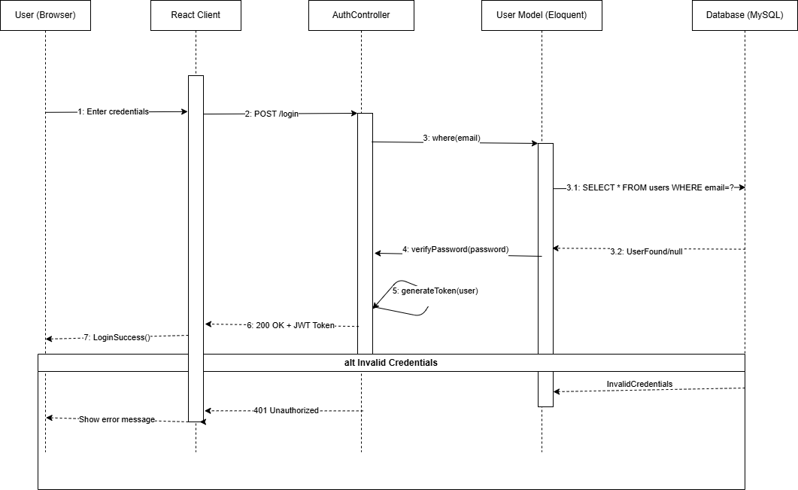Figure 3.8: Login Sequence Diagram

3.2.5.2 View Service Details Sequence Diagram
This sequence diagram illustrates the process of viewing detailed information for a selected service. It demonstrates how the system retrieves the service data, associated images, and category information from the database.
Main Flow Includes:
- Requesting service details
- Retrieving service information from the database
- Returning a JSON response
- Rendering the service details page
Alternative Flow:
- Service not found → system returns a 404 error
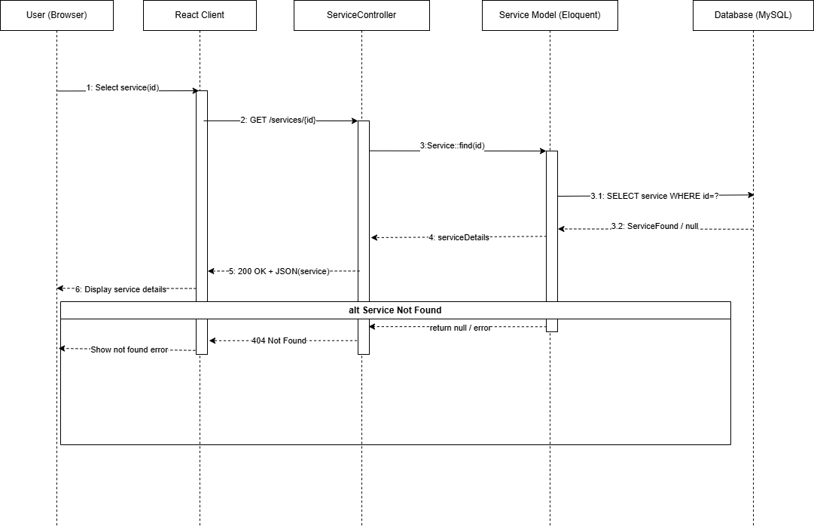Figure 3.9: View Service Details Sequence Sequence Diagram

3.2.5.3 Add Service Sequence Diagram
This diagram describes the steps involved in creating a new service within the system. It shows how service data is submitted, validated, and stored, along with the upload and storage of service images.
Main Flow Includes:
- Submitting service form data
- Validating input data
- Creating a new service record
- Uploading and storing service images
- Returning a success response
Alternative Flow:
- Invalid input or image format → system returns a validation error
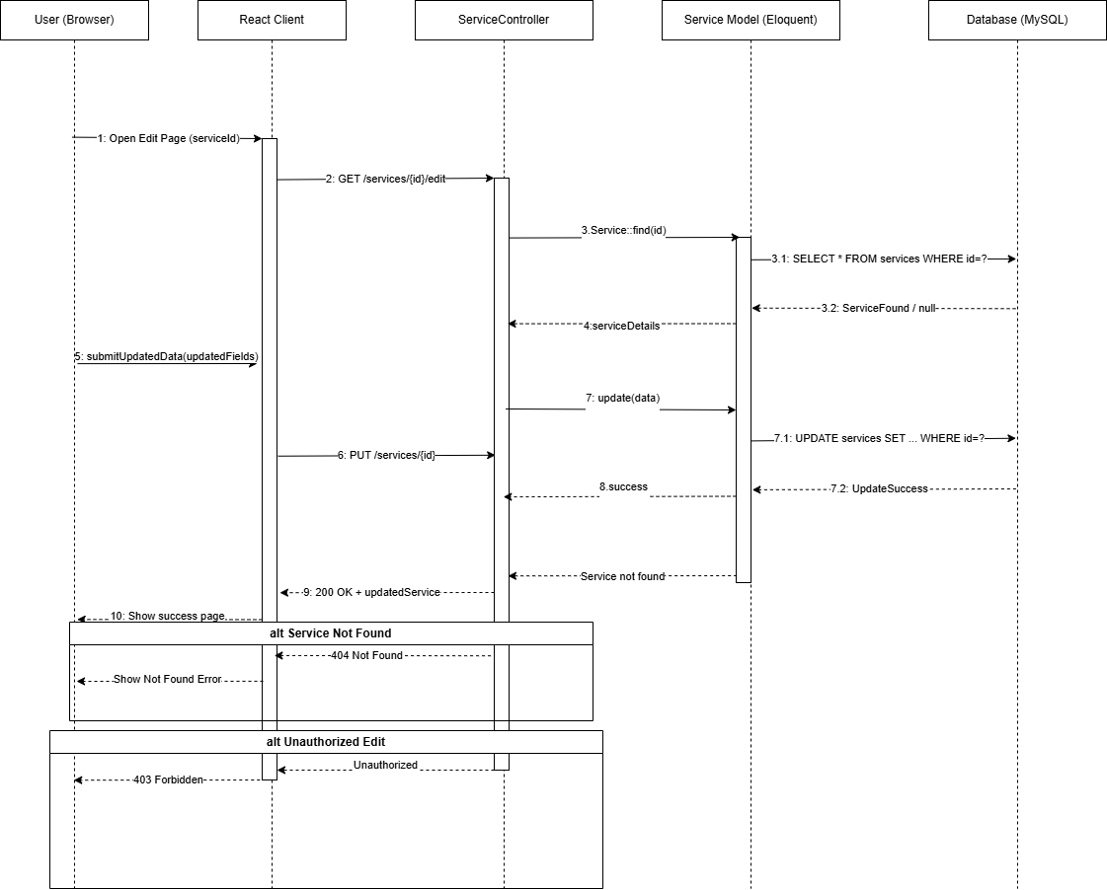Figure 3.10: Add Service Sequence Sequence Diagram

3.2.5.4 Edit Service Sequence Diagram
This sequence diagram explains how an existing service is updated by its owner. It highlights the process of retrieving current service data, applying updates, and saving the changes to the database.
Main Flow Includes:
- Fetching existing service data
- Submitting updated service information
- Validating user authorization
- Updating the service record
Figure 3.11: Edit Service Sequence Sequence Diagram

3.2.5.5 Delete Service Sequence Diagram
This diagram illustrates the process of deleting a service by its owner. It shows how the delete request is validated and executed within the system.
Main Flow Includes:
- Submitting a delete request
- Validating ownership and permissions
- Removing the service record from the database
- Returning a deletion confirmation
Alternative Flow:
- Service not found → system returns a not found error
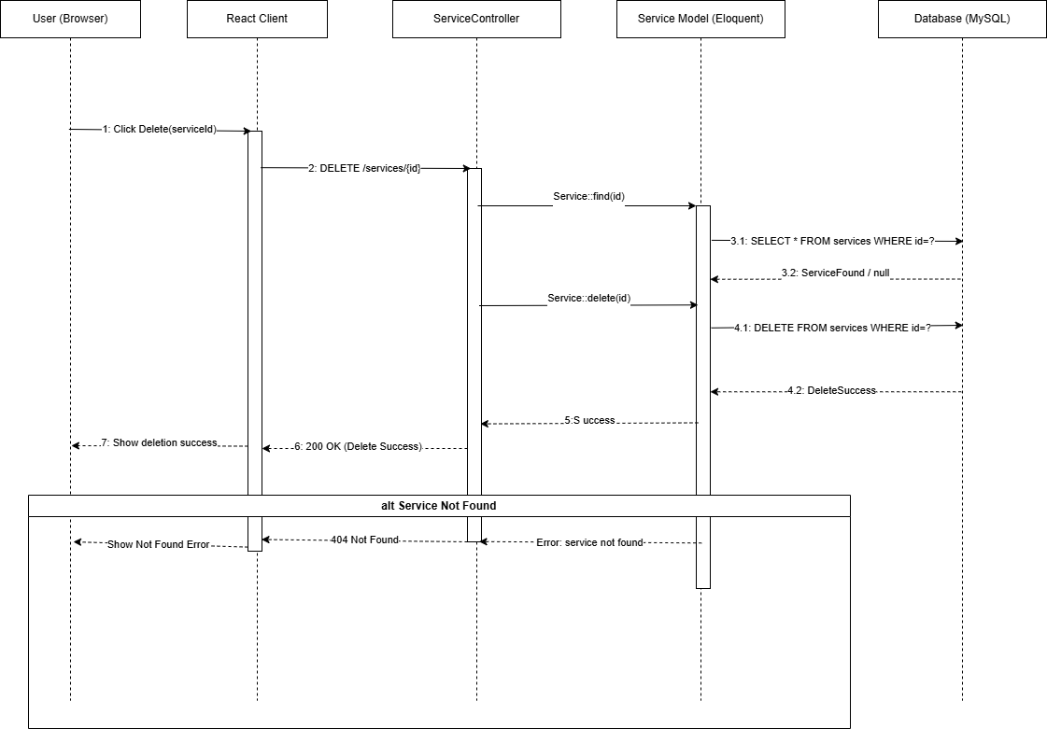Figure 3.12: Delete Service Sequence Sequence Diagram

3.2.5.6 Manage Users Sequence Diagram
This sequence diagram demonstrates how the system administrator manages user accounts through the admin panel. It shows the retrieval of user data and the updating of user account status.
Main Flow Includes:
- Requesting the list of users
- Retrieving user data from the database
- Updating user account status (activate/deactivate)
- Returning an updated response
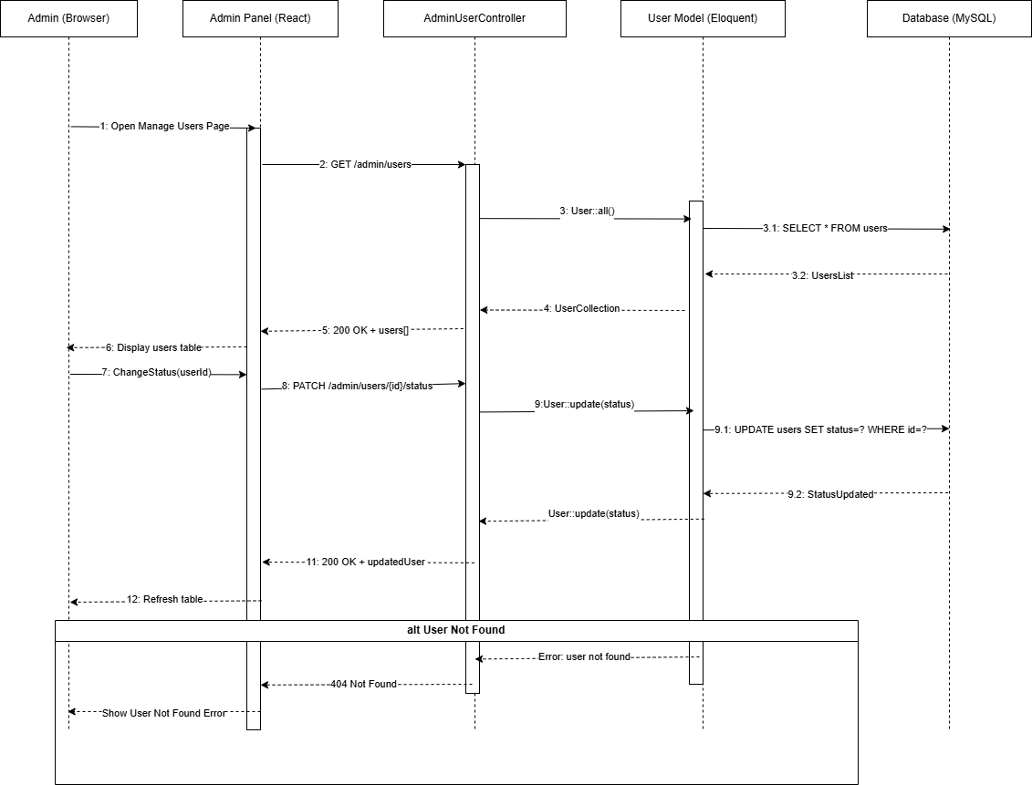Figure 3.13: Add Service Sequence Sequence Diagram

3.3 Database Design
The database of the DirectServe Platform was carefully designed to meet the system requirements while ensuring data consistency, minimizing redundancy, and providing efficient and fast data access. A relational database model was adopted to support scalability, maintain integrity, and facilitate clear relationships between system entities.

3.3.1 Entity Relationship Diagram (ERD)
The Entity Relationship Diagram (ERD) illustrates the main entities of the system and the relationships between them. The primary entities included in the database design are:
- Users
- Services
- Categories
- ServiceImages
- Messages
- Reviews
- Roles
- Tags
- Services_has_Tags (Many-to-Many relationship)
The key relationships in the database include:
- Each user can create and manage multiple services.
- Each service belongs to a single category.
- Each service can have multiple images and reviews.
- Services can be associated with multiple tags through a linking (junction) table to support a flexible tagging system.

3.3.2 Database Table Descriptions
1. Users Table
Stores all user-related information, including:
- user_id
- name
- email
- password
- role
- created_at
2. Services Table
Contains information related to the services provided by users, such as:
- service_id
- title
- description
- price
- provider (user_id)
- category_id
- created_at / updated_at
3. Categories Table
Stores the predefined service categories used to organize services.
4. ServiceImages Table
Stores URLs and references to images associated with each service.
5. Reviews Table
Contains user reviews and ratings submitted for services.
6. Messages Table
Stores messages and inquiries exchanged between users through the platform.
7. Roles Table
Defines the different system roles such as Administrator, Provider, and Customer, which are used for role-based access control.
8. Tags and Services_has_Tags Tables
Used to classify services using a flexible tagging mechanism that supports a many-to-many relationship between services and tags.
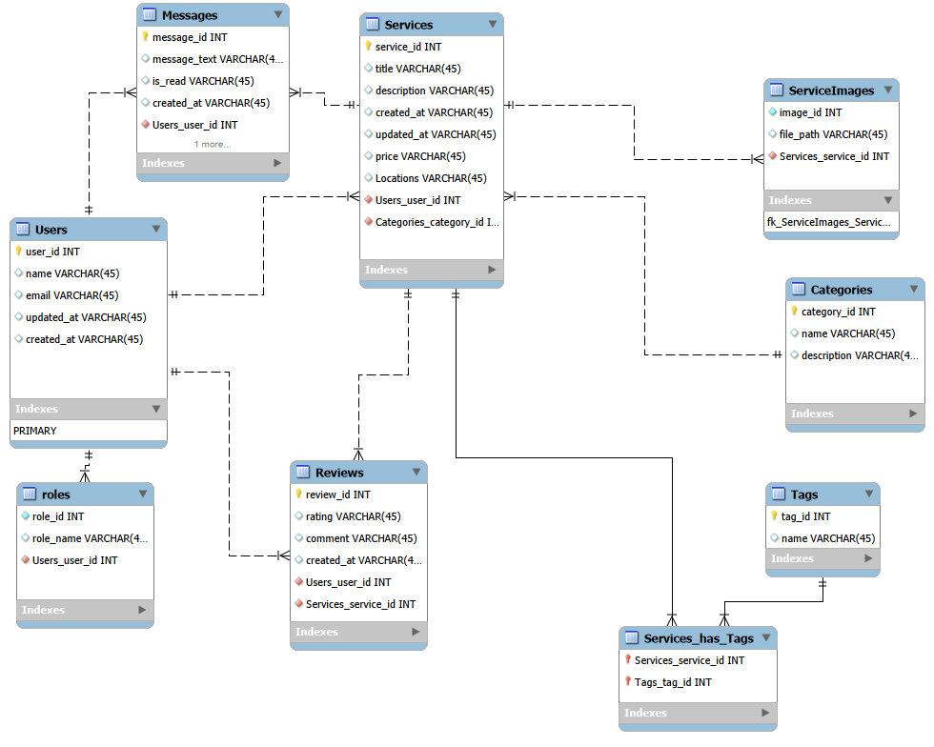Figure 3.14:ERD Diagram

3.4 Main User Interface Descriptions
The user interfaces of the DirectServe Platform were designed using modern UI/UX principles to ensure clarity, consistency, and ease of use. The interfaces aim to provide a smooth and intuitive experience for all types of users, including visitors, service providers, and administrators. Special attention was given to responsiveness, accessibility, and visual consistency across different devices and screen sizes.
A complete high-fidelity prototype was designed using Figma, covering the entire user journey from authentication to service management. This prototype served as a reference during the front-end development phase and helped maintain a unified design system throughout the platform
3.4.1 Login Page
The login page provides a simple and clean interface that allows users to access the platform using their email and password. It includes input fields for authentication, a login button, and a link for password recovery. A redirect option is also provided for new users to navigate to the registration page. The design focuses on minimizing user effort and ensuring a clear authentication process.
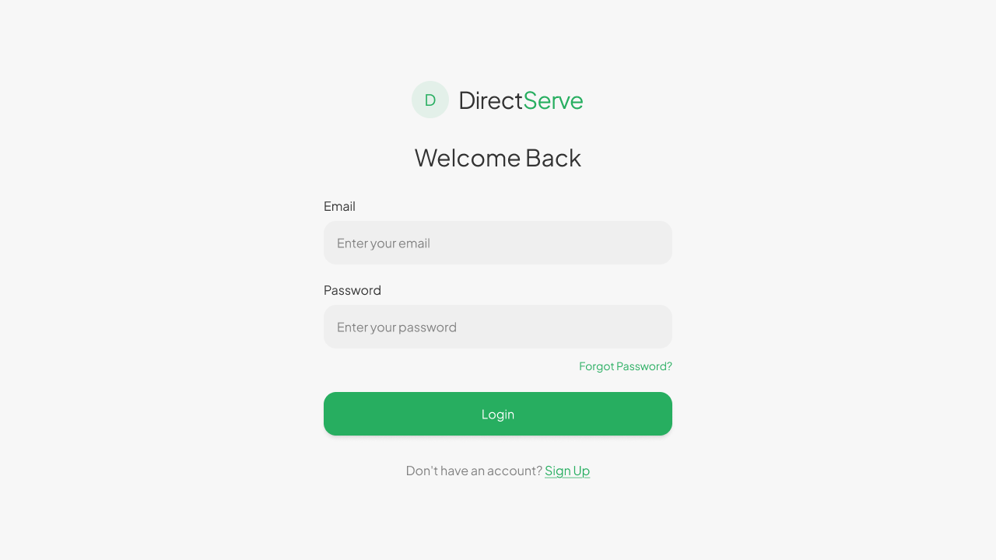Figure 3.15: Login Page

Related Use Cases: [ UC02 – Login , UC01 – Create Account]

3.4.2 Home Page
The home page serves as the main entry point to the platform. It highlights the core features of the system, such as browsing services, searching by keywords, and exploring service categories. The page includes a search bar, featured services, popular categories, and a list of recently added services. This layout helps users quickly discover available services and navigate efficiently.
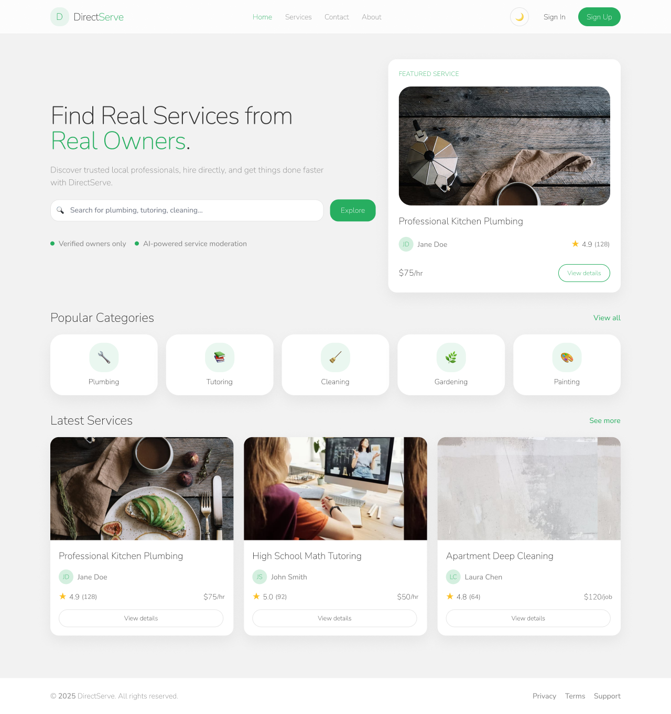Figure 3.16: Home Page

Related Use Cases: [ UC03 – View Services, UC04 – Search Services, UC06 – Contact Us ]

3.4.3 Services Listing Page (Find a Service)
The services listing page displays available services in a structured grid or card-based layout. Users can search for services using keywords and apply filters such as category or price range. Each service card presents essential information including the service title, thumbnail image, price, and rating, enabling users to compare services easily.
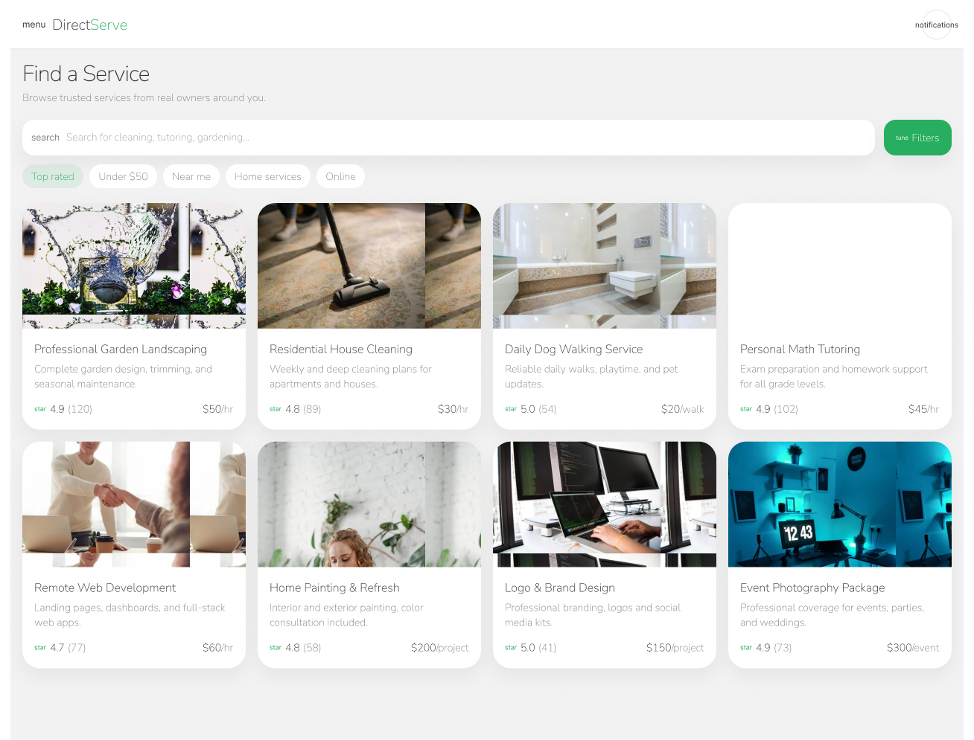Figure 3.17: Find a Service Page

Related Use Cases: [ UC03 – View Services, UC04 – Search Services ]

3.4.4 Service Details Page
The service details page provides comprehensive information about a selected service. It includes a gallery of service images, service description, price details, category information, and provider details. This page is designed to build user trust by presenting all relevant information in a clear and organized manner before the user initiates contact.
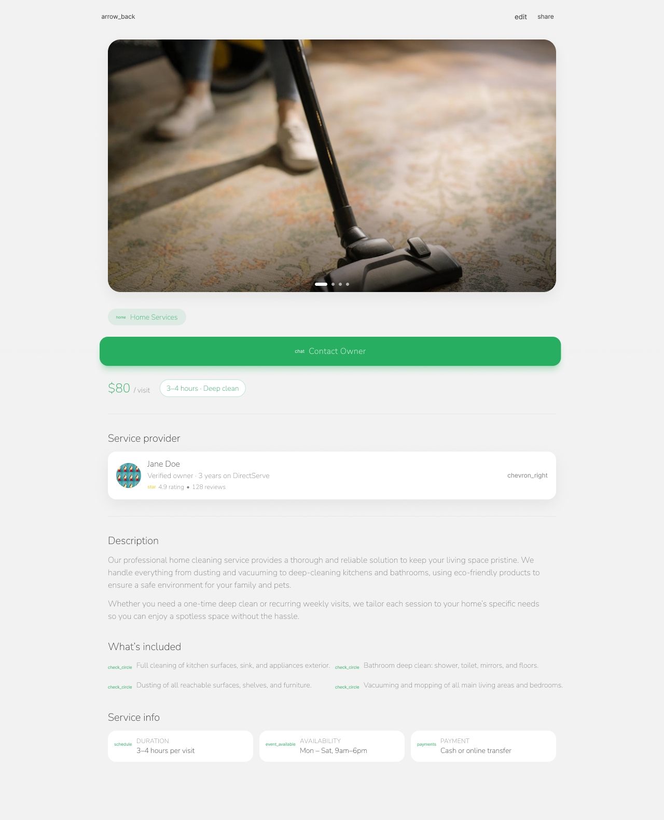
Figure 3.18: Service Details Page
Related Use Cases: [ UC05 – View Service Details ]

3.4.5 Dashboard (Service Provider Dashboard)
The dashboard is designed specifically for service providers to manage their services efficiently. It displays an overview of the provider’s services, including the number of active and draft services. The dashboard also provides quick access to actions such as adding a new service, editing existing services, or deleting services.
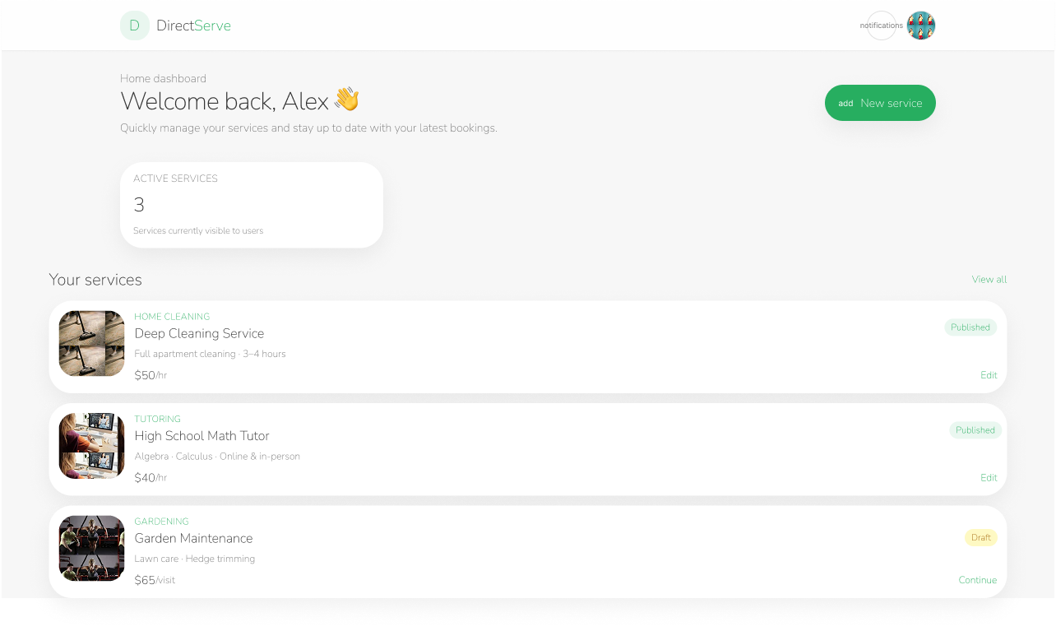Figure 3.19: Dashboard Page

Related Use Cases: [ UC15 – Manage Users, UC16 – Manage Services, UC17 – View Messages, UC18 – Manage Categories, UC19 – Manage Roles, UC20 – Manage Tags ]

3.4.6 Add New Service Page
The add new service page allows service providers to create and publish new services. The interface includes structured input fields for service details such as title, description, category, price, location, tags, and images. Clear action buttons are provided to submit the service or save it as a draft, ensuring a smooth service creation process.
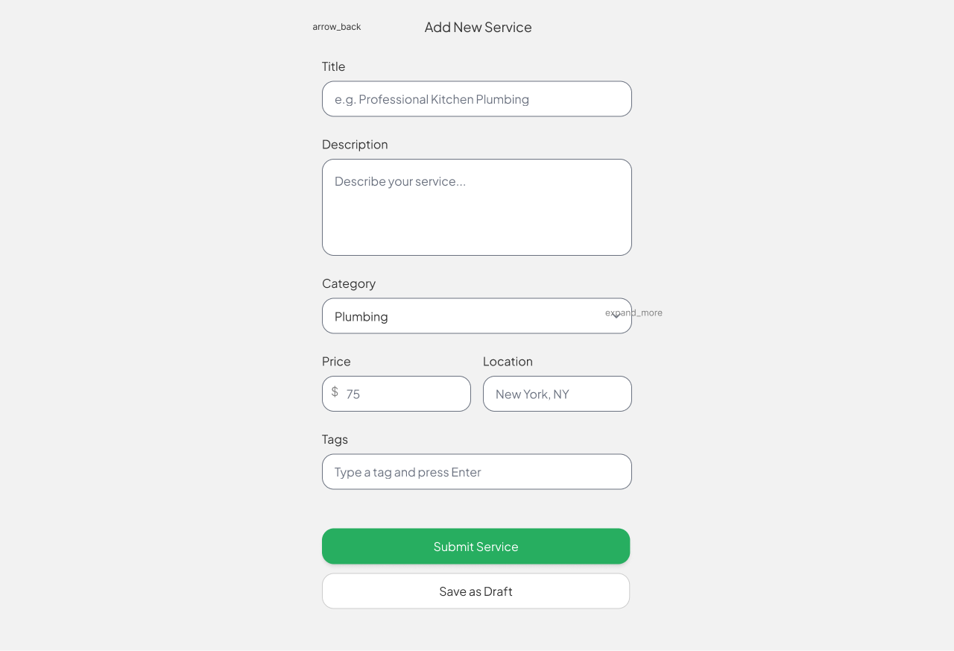Figure 3.20: add new service Page

Related Use Cases: [ UC10 – Add Service, UC13 – Manage Service Gallery ]

3.4.7 Edit Service Page
The edit service page enables providers to update existing service information or manage the service gallery. The page contains pre-filled fields to simplify editing and includes options to add or remove images. The design mirrors the add service page to maintain consistency and reduce the learning curve for users.
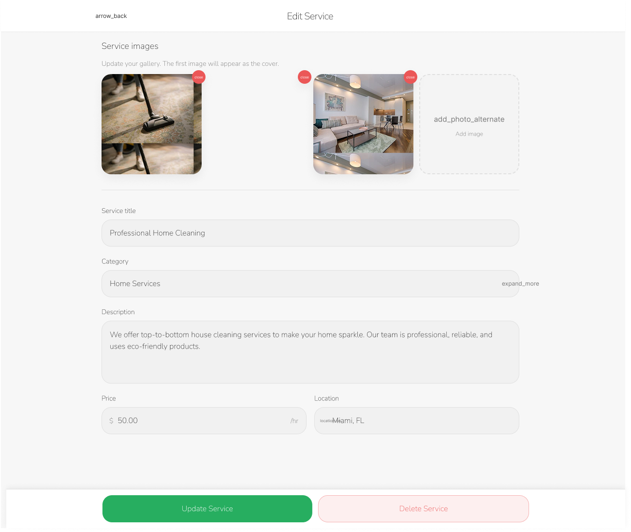Figure 3.21: edit service Page

Related Use Cases: [ UC11 – Edit Service, UC12 – Delete Service ]

Chapter 4: Timeline and Challenges
This chapter presents the project work plan, task distribution among team members, the development timeline, and the main challenges encountered during the implementation of the DirectServe Platform, along with the solutions adopted to address them.

4.1 Work Plan and Task Distribution
The work plan was structured to ensure balanced contribution from all team members while maintaining an efficient workflow and effective collaboration. Tasks were distributed based on technical expertise, specialization, and overall project requirements to maximize productivity and quality.
Table 4.1.1: Team Members and Responsibilities
Team member | Responsibilities
Munir Z. A. Alghriz | Backend development, API architecture, database design, authentication & authorization implementation
Mutassembelah M. Alsaifi | Front-end development (React), UI integration, service, pages dashboards, state management
Ahmed M. Al-Zayyan | UI/UX design (Figma) , documentation, sequence diagrams, testing & quality assurance

General Work Approach
The team followed an organized and collaborative development approach, which included:
- Weekly team meetings for progress evaluation and coordination
- Shared version control using GitHub
- Task management and tracking using Trello
- Continuous integration between the front-end and back-end components
- Iterative testing after completing each development module

4.2 Project Timeline
The development of the DirectServe Platform was planned across multiple phases, with each phase focusing on a major functional milestone. This structured timeline helped ensure steady progress and timely completion of the project.
Estimated Timeline Phases:
- Requirements Analysis (Weeks 1–2)
Gathering functional and non-functional requirements and defining the system scope.
- System Design (Weeks 3–4)
Creating UML diagrams, database ERD, system architecture, and UI/UX prototypes.
- Backend Development (Weeks 5–7)
Implementing APIs, database integration, authentication, authorization, and core CRUD operations.
- Front-End Development (Weeks 8–10)
Developing main user interfaces, service pages, forms, dashboards, and client-side logic.
- Integration and Testing (Weeks 11–12)
Integrating front-end with back-end services, debugging issues, and improving system performance.
- Final Review and Documentation (Week 13)
Preparing the final report, polishing the user interface, and ensuring full system functionality.

4.3 Challenges and Solutions
During the development of the DirectServe Platform, several technical and design challenges were encountered. Addressing these challenges contributed significantly to improving the system’s quality and reliability.
1. API Integration Between Front-End and Back-End
Challenge: Ensuring smooth communication between RESTful APIs and the React client, especially in handling JSON responses and error messages.
Solution:
- Standardized API response structures
- Used Postman for API testing before integration
- Implemented validation and error-handling mechanisms
2. Handling File Uploads (Service Images)
Challenge: Uploading, storing, and linking service images correctly with database records.
Solution:
- Organized image storage structure
- Validated image size and format
- Implemented loop-based upload handling
3. Database Scalability and Structure
Challenge: Designing a database that supports tags, reviews, messages, and service categories without redundancy.
Solution:
- Used a normalized relational database schema
- Implemented many-to-many relationships using linking tables
- Applied indexing and foreign key constraints
4. Consistent UI/UX Design
Challenge: Maintaining a unified and responsive design across all interfaces.
Solution:
- Designed a complete Figma prototype before development
- Defined consistent design rules for colors, spacing, and typography
- Reused UI components across different pages
5. Cross-Device Compatibility
Challenge: Ensuring consistent performance across desktop and mobile devices.
Solution:
- Applied responsive design principles
- Tested across multiple screen sizes
- Optimized images and applied lazy loading where applicable

4.4 Summary
The DirectServe Platform was developed successfully according to the planned timeline and project objectives. Effective task distribution, structured planning, and proactive problem-solving enabled the team to overcome development challenges and deliver a scalable, user-friendly, and reliable web-based service platform.

References
- React Documentation. (2024). React Official Documentation. Available at:
https://react.dev
- Figma. (2024). Figma Design System and Prototyping Tools. Available at:
https://www.figma.com
- JWT Authentication. (2024). JSON Web Token Documentation. Available at:
https://jwt.io
- RESTful API Guidelines. (2023). REST API Best Practices. Available at:
https://restfulapi.net
- UML Diagrams Guide. (2023). Unified Modeling Language (UML) Overview. Available at:
https://www.uml-diagrams.org
- W3Schools. (2024). HTML, CSS, and JavaScript References. Available at:
https://www.w3schools.com
- DirectServe Platform – Figma Prototype. (2025). UI/UX Interactive Design. Available at:
DirectServe

Appendices

Appendix A: UML Diagrams
This appendix includes all UML diagrams used in the system design phase, providing a visual representation of the system structure and behavior. The diagrams included are:
- Sequence Diagrams
- Class Diagram

Appendix B: Database ERD
This appendix contains the complete Entity Relationship Diagram (ERD) of the database, along with detailed descriptions of all database tables and their relationships. It serves as a reference for understanding the data structure and database design decisions.

Appendix C: Figma UI/UX Screens
This appendix includes all user interface screens designed for the DirectServe Platform using Figma. These screens illustrate the visual design and user experience flow of the system, including:
- Login Page
- Home Page
- Services Listing Page
- Service Details Page
- User Dashboard
- Add Service Page
- Edit Service Page

